Practical 1

1. whoami

- The whoami command reveals your current username within the Linux system.
2. pwd

- The pwd command (short for "print working directory") displays your current location within the file system hierarchy.

3. ls

- The ls command (short for "list") displays the contents of a directory, showcasing its files and subdirectories.

4. ls -r

- The ls -r command displays the contents of a directory in reverse alphabetical order.

5. ls-a

- The ls -a command lists all files and directories within a specified directory, including hidden files.

6. history
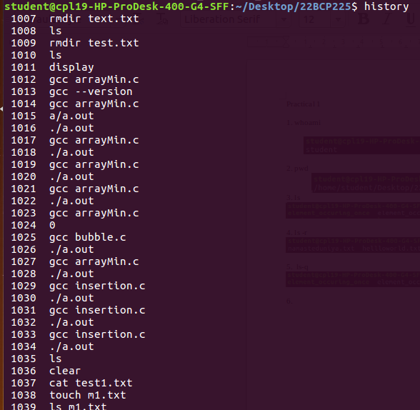
- The history command displays a list of recently executed commands in your terminal session, acting as a record of your activity.

7. clear

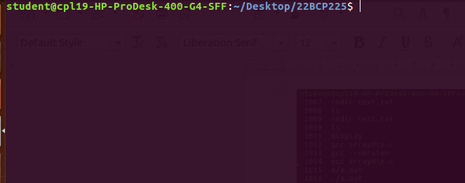
- The clear command erases all previous output and prompts from the terminal screen, providing a fresh, uncluttered workspace.

8. echo

- The echo command prints text or variables to the terminal screen, bringing your words to life within the command-line environment.

9. chmod

- Change the access permissions of files and directories.
10. wc

- The wc command, short for "word count," counts the number of lines, words, and characters in files or text input.

11. touch

- The touch command is used to create new, empty files or update the timestamps of existing files. It's like giving a gentle tap to a file, either bringing it into existence or giving it a fresh timestamp.

12. rm

- The rm command, short for "remove," is used to delete files and directories in Unix-like operating systems. Imagine it as a powerful shredder for your digital files, capable of erasing them permanently.

13. mkdir

- The mkdir command, as you likely know, stands for "make directory" and is used to create new directories in Unix-like operating systems like Linux and macOS. It's the digital equivalent of building folders to organize your files effectively.

14. rmdir

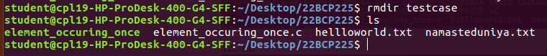
- The rmdir command, short for "remove directory," is used to delete empty directories in Unix-like operating systems. Think of it as a specialized crew that dismantles empty folders, clearing space in your file system.

15. mv

- The mv command, short for "move," is used to move files and directories or rename them within a file system. Think of it as a digital moving crew that efficiently relocates or relabels your files and folders.

16. cd

- The cd command, short for "change directory," is like your personal teleportation device within the terminal. It allows you to navigate through different directories in your file system, effectively changing your working location.

17. cmp

- The cmp command, short for "compare," is used to compare two files byte by byte, identifying any differences between them. It's like a meticulous detective, carefully examining every detail to uncover discrepancies.

18. cat

- The cat command, short for "concatenate," is used to display, create, and concatenate (join together) files in Unix-like operating systems. Imagine it as a versatile tool that can reveal the contents of files, craft new ones, and merge them seamlessly.

19. comm

- The comm command acts as a file comparator, meticulously identifying and organizing lines that are unique or shared between two sorted text files. Think of it as a skilled librarian sorting books based on their titles, highlighting those found in one library but not the other, and neatly arranging those present in both.

20. date

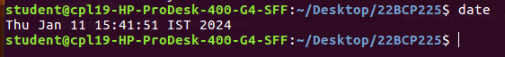

- The date command is like your personal timekeeper within the terminal, providing various ways to display and manipulate date and time information. It's like having a clock, calendar, and time-travel device all in one.

21. cal

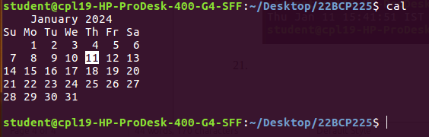
- The cal command is your handy pocket calendar within the terminal, displaying neatly organized monthly calendars for keeping track of dates and planning ahead. It's like summoning a virtual wall calendar for a quick glance at the month's layout.

22. passwd

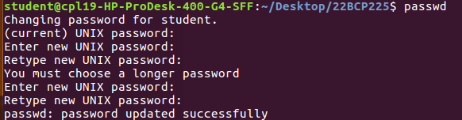
- The passwd command acts as the gatekeeper for your user account's password, allowing you to change it, set a new one, or enforce security policies in Unix-like operating systems. It's like a vigilant security guard ensuring only authorized individuals can access your digital space.

23. grep

- The grep command, short for "global regular expression print," is a powerful text-searching tool that acts like a tireless detective, scanning through files to uncover specific patterns or keywords you're looking for. It's a staple for anyone working with text data in the terminal.
24. free

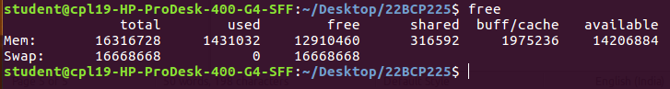
- The free command is your personal memory inspector, providing a real-time snapshot of how your system's memory is being used. It's like taking a peek under the hood of your computer to see how much memory is available for tasks and how much is occupied.

25. uname

- The uname command (short for "Unix name") acts as your system's ID card, revealing key details about its operating system and hardware architecture. It's like asking your computer to introduce itself and share its background information.

26. groups

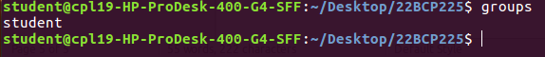
- The groups command acts as a group membership identifier, revealing the user groups to which a particular user belongs. Think of it as checking a person's club memberships to understand their roles and access privileges within a system.d

